Fluorexetamine and 2-Fluoro-2-oxo PCE. An Encounter with Coemerging Isomeric NPS Dissociatives.

Danai T. Taruvinga MS., D-ABFT-FT, Heather L. Ciallella PhD, and Luigino G. Apollonio PhD

Cuyahoga County Medical Examiner’s Office and Regional Forensic Science Laboratory, 11001 Cedar Avenue, Cleveland, Ohio 44106, USA

Introduction
New arylcyclohexylamine derivatives (NADs) are ketamine and phencyclidine-based analogues that contain a cyclohexane ring attached to phenyl and amine groups on the same ring atom^{1,2}. Dissociatives like NADs act as antagonists on the N-methyl-d-aspartate receptor and distort sensory perception³. Here, we discuss an example of analytical challenges faced when a forensic toxicology laboratory encounters isomeric novel psychoactive substances (NPS). We share Cuyahoga County Regional Forensic Science Laboratory’s (CCRFSL’s) experience with the fluorexetamine (FXE) and its positional isomer 2-fluoro-2-oxo Phenylcylohexylethylamine (2-fluoro-2-oxo PCE) [Fig. 1].
The CCRFSL Toxicology Unit performs testing on postmortem, impaired driving, and drug-facilitated crime cases. With our current scope, the regional NPS drug trends are characterized by a prevalence of fentalogues, nitazenes, and designer benzodiazepines. Generally, incidences of NADs such as 3-hydroxy-PCP and 2-fluorodeschloroketamine have been less in comparison.

Methods
Comprehensive toxicology testing at the CCRFSL includes basic drug screening by full-scan gas chromatography/mass spectrometry (GC/MS) in blood and urine. The samples are extracted by solid-phase extraction, and analysis is performed on a Hewlett-Packard 6890/5973 GC/MS equipped with a Restek Rxi-5ms, 30 m x 0.25-mm i.d., 0.25-µm film thickness (Bellfonte, PA, USA) column for a total run time of 24 minutes for both blood and urine methods. Data analysis and analyte identification is achieved via probability-based library matching with mass spectral libraries. The retention times of the analytes must be compared to a retention time mix of certified reference materials (CRMs) injected with every batch to meet reporting criteria. A peak’s relative retention time (RRT) must be within 2% of the RRT of the analyte in the retention time mix to be reportable. The mass spectral fragmentation pattern must also contain a minimum of five diagnostic fragments. If a particular analyte that is not in the retention time mix is encountered, the sample is re-extracted and analyzed with a CRM.

Results
Between December 2022 and March 2023, the CCRFSL received three NAD cases where evidence was received for both toxicological and drug chemistry analyses. Two of these were postmortem overdose cases, and the third was an impaired driving case. Notable seized evidence included a bag of white powder labelled “Fluorexetamine” associated with the impaired driving case, and blue pills that were coded to be Oxycodone Hydrochloride 30 mg that were found on the scene of a postmortem case. During toxicology testing, all three cases found signals identified as FXE by the Scientific Working Group for the Analysis of Seized Drugs (SWGDRUG) mass spectral library [Fig 2-3].
Discovering the existence of the FXE isomer, 2-fluoro-2-oxo-PCE, came as a result of analytical testing that was performed on the seized drugs by the Drug Chemistry Unit after toxicology testing had concluded. Drug chemists at CCRFSL learned that FXE had an isomer during this time and purchased a CRM for 2-fluoro-2-oxo PCE. Upon testing, all three reports listed evidence items containing 2-fluoro-2-oxo PCE, including the white powder and blue pills. These findings triggered a reassessment of the toxicology data. Equipped with a CRM for 2-fluoro-2-oxo PCE, chromatographic resolution was achieved between the two isomers [Fig. 4]. The identification of both isomers was accomplished using the current version of the Cayman Chemical Company mass spectral library (CaymanSpectralLibrary_v14022023).

Discussion and conclusion
The highly analogous mass spectra, compounded by a retention time difference of just over 1%, aided in misidentifying 2-fluoro-2-oxo PCE as FXE. As highlighted in Fig.4 and reported by Yen et al., m/z 95 can discriminate between the two⁴. This situation had the added complication of inconsistent chemical nomenclature, making literature review difficult. 2-fluoro-2-oxo PCE has been reported under the names 2-fluorodeschloro-N-ethyl-ketamine (2-FDCNEK) by researchers in China⁴, and 2-fluoro-N-ethylnordeschloroketamine (2F-NENDCK) and “CanKet” by researchers in Australia⁵. On the other hand, FXE is infrequently referred to by the name 3-fluoro-2-oxo Phenylcylohexylethylamine (3-fluoro-2-oxo PCE), which links it to its isomer more intuitively. For all three cases, stakeholders were made aware of these findings.
First encounters with emerging NPS drugs and isomers are difficult to navigate when information regarding them is sparse. These drugs can be challenging to correctly identify even when the identification of the peak in question meets reporting criteria. We found that real-time collaboration with drug chemists widens the general pool of knowledge and serves an invaluable tool for toxicologists in the current NPS climate. Our experience stresses that the dynamic nature of the NPS climate calls for vigilant screening and identification protocols to avoid overlooking these drugs.

Acknowledgements
The authors would like to thank staff of the CCRFSL Toxicology Unit, namely Rindi Rico and Christie Michell-Mata, who identified FXE in routine casework, and Shaena Taylor and the staff of the CCRFSL Drug Chemistry Unit.

Disclosures
The authors have no conflicts of interest to disclose.

Additional Note
This information was presented as part of a greater work at the 2023 Society of Forensic Toxicologists Meeting, October 33–November 3, 2023, in Denver Co. S-27: Fluorexetamine and 2-fluoro-2-oxo Phenycyclohexylethylamine: New Dissociative Hallucinogens in Forensic Toxicology and Drug Chemistry Casework.

References
(1) Morris, H.; Wallach, J. From PCP to MXE: A Comprehensive Review of the Non‐medical Use of Dissociative Drugs. Drug Test. Anal. 2014, 6 (7–8), 614–632. https://doi.org/10.1002/dta.1620.
(2) Gicquel, T.; Richeval, C.; Mesli, V.; Gish, A.; Hakim, F.; Pelletier, R.; Cornez, R.; Balgairies, A.; Allorge, D.; Gaulier, J. Fatal Intoxication Related to Two New Arylcyclohexylamine Derivatives (2F-DCK and 3-MeO-PCE). Forensic Sci. Int. 2021, 324, 110852. https://doi.org/10.1016/j.forsciint.2021.110852.
(3) Anis, N. A.; Berry, S. C.; Burton, N. R.; Lodge, D. The Dissociative Anaesthetics, Ketamine and Phencyclidine, Selectively Reduce Excitation of Central Mammalian Neurones by N-Methyl-Aspartate. Br. J. Pharmacol. 1983, 79 (2), 565–575. https://doi.org/10.1111/j.1476-5381.1983.tb11031.x.
(4) Yen, Y.-T.; Tsai, Y.-S.; Su, W.-L.; Huang, D.-Y.; Wu, H.-H.; Tseng, S.-H.; Wang, H.-H.; Chiu, C.-Y.; Wang, C.-F.; Liu, C.-Y.; Chyueh, S.-C. New Ketamine Analogue: 2-Fluorodeschloro-N-Ethyl-Ketamine and Its Suggested Metabolites. Forensic Sci. Int. 2022, 341, 111501. https://doi.org/10.1016/j.forsciint.2022.111501.
(5) David Caldicott; Malcolm McLeod. An entirely new illicit drug has been discovered by Australian chemists. Here’s how they did it. ANU College of Science. https://science.anu.edu.au/news-events/news/entirely-new-illicit-drug-has-been-discovered-australian-chemists-heres-how-they (accessed 2024-01-13).

Figures

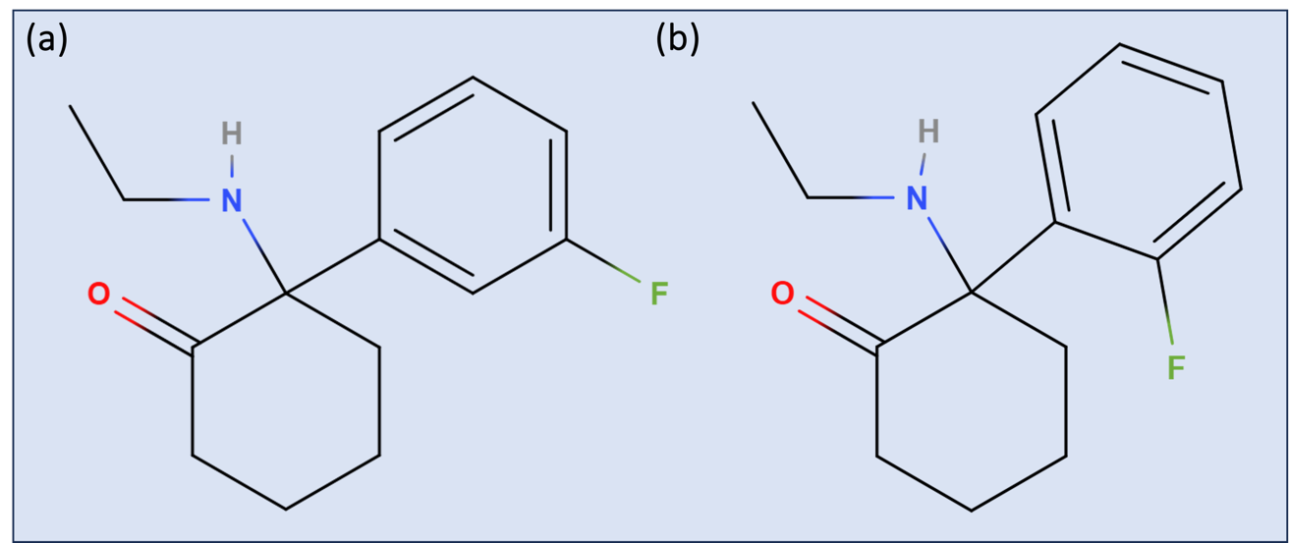
Figure 1. Structures of FXE (a) and 2-fluoro-2-oxo PCE (b)

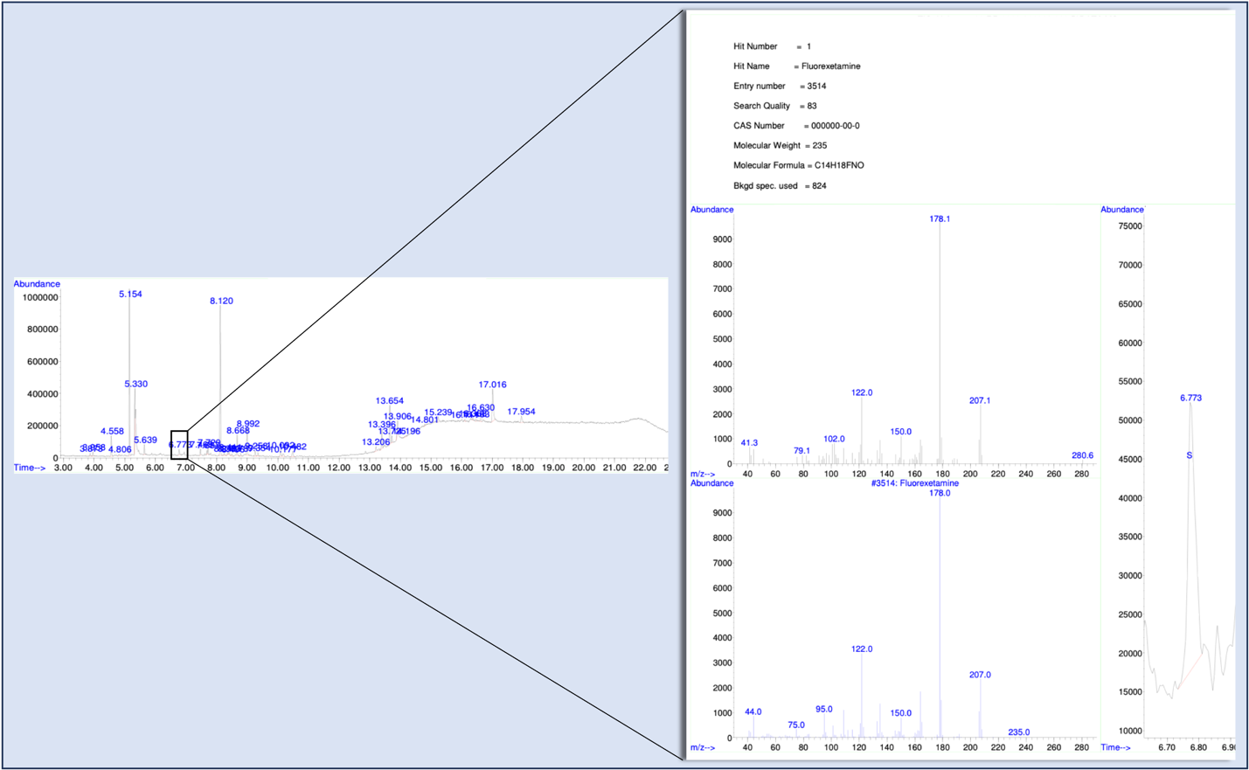
Figure 2. The CCRFSL’s first encounter with a chromatographic peak originally identified as FXE by the SWGDRUG mass spectral library (femoral blood).

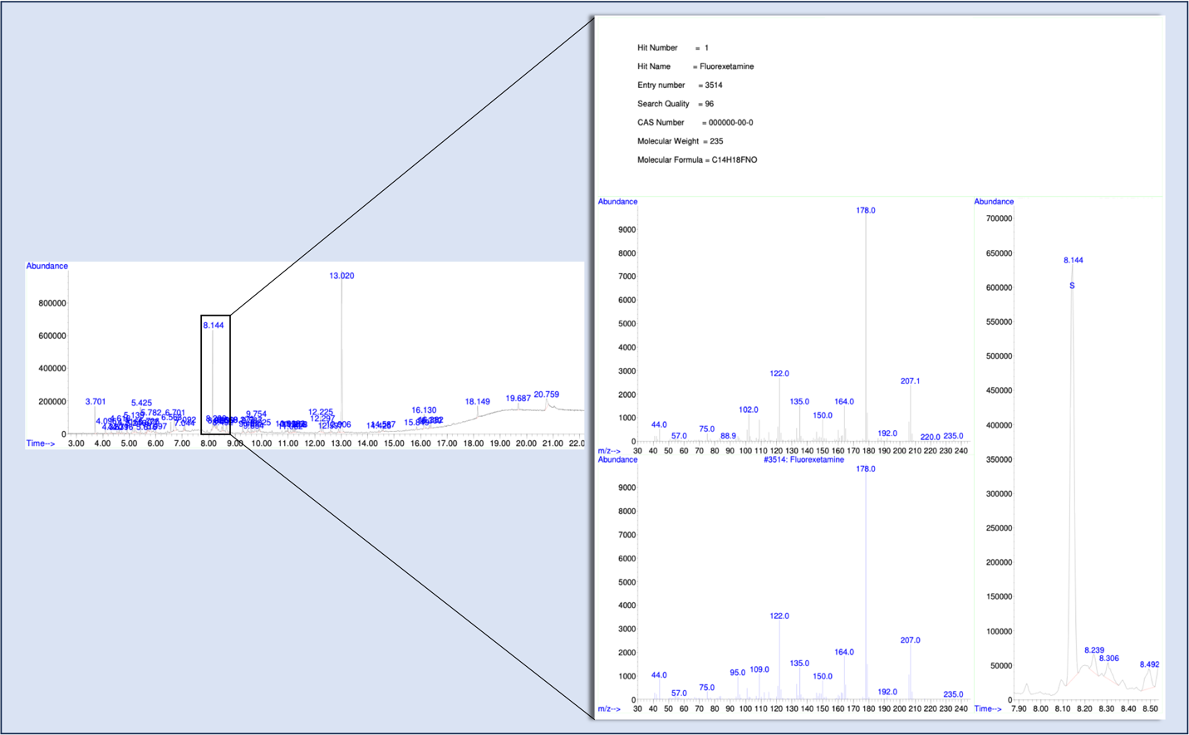
Figure 3. The CCRFSL’s first encounter with a chromatographic peak originally identified as FXE by the SWGDRUG mass spectral library (postmortem urine).

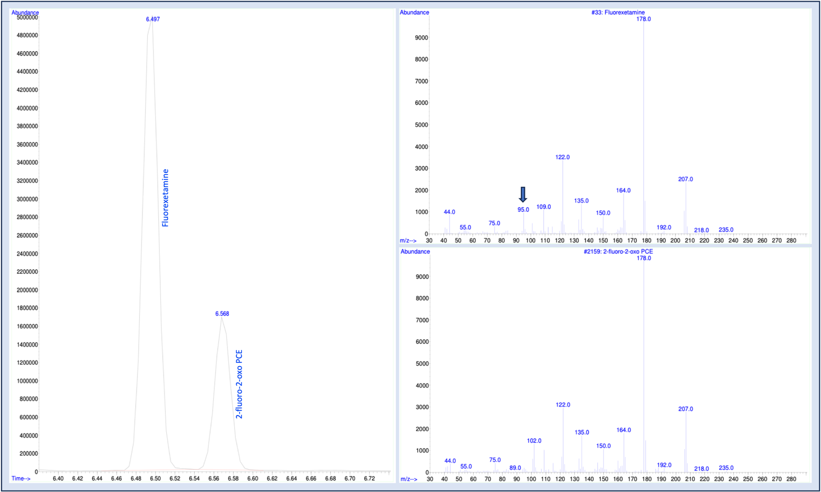
Figure 4. Chromatographic resolution and identification of FXE and 2-fluoro-2-oxo PCE using CRMs purchased from Cayman Chemical Company (Ann Arbor, MI, USA) and their respective mass spectra as identified by the Cayman Chemical Company mass spectral library.

